**Witchcraft and womanhood explored in a unique Gothic setting**

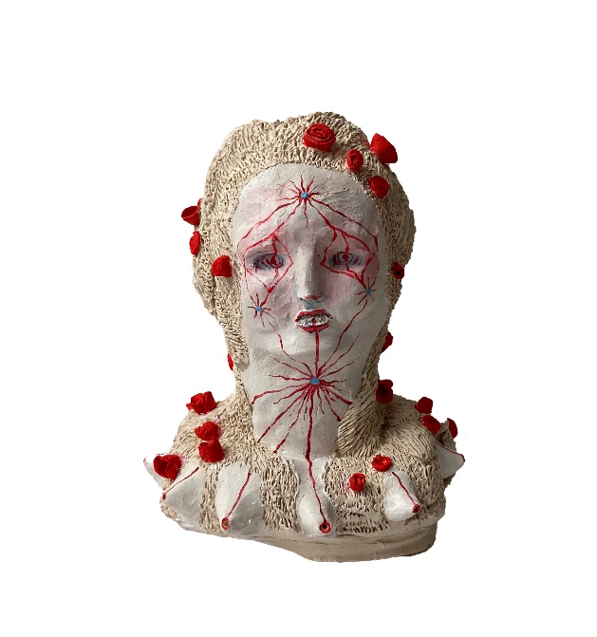

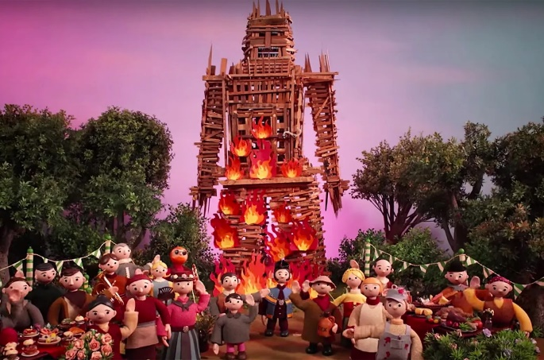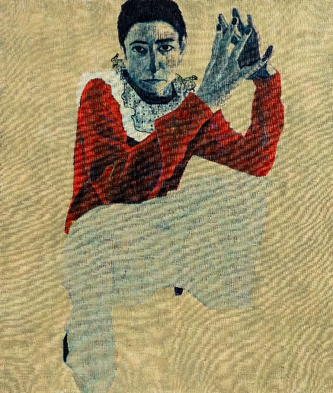

***The Witch Burns***

**TIN MAN ART at Fitzrovia Chapel  
Fitzroy Place  
2 Pearson Square  
London W1T 3BF**

**Tuesday 2nd - Friday 12th July**

For two weeks in July, works by some of the leading names in contemporary art will be displayed at Fitzrovia Chapel in an exploration of witchcraft, womanhood, feminism and satire.

*The Witch Burns* includes artists such as Sara Berman, Radiohead & Chris Hopewell, Malene Hartmann-Rasmussen, Tim Noble & Sue Webster, Zach Toppin and Nooka Shepherd, whose works delve deep into our continuing obsession with witches, female power and proto-religious imagery. A new work by Sue Webster will also be shown for the first time.

This unique exhibition, curated by TIN MAN ART, will be hosted in London’s Fitzrovia Chapel, a Grade II-listed Gothic-revival building, originally built as a place for reflection and contemplation for staff and patients at the former Middlesex Hospital. Never fully consecrated, it has over the last decade—after a £2 million restoration, particularly to its extraordinary gold mosaic ceiling—become a key spot in London’s contemporary art scene.

To many, the witch figure has been associated with evil and persecution for almost 1,000 years. The counterview that gives rise to the witch as a symbol of power and feminine resistance has been growing for some time, helping us re-evaluate the role and representation of women and anyone who is deemed as ‘other’ in society.

The works on display will show how contemporary art is currently challenging and redefining concepts of power, persecution and piety. By inverting religious iconography and classic Christian imagery, modern feminist thought can be brought to the concept of the witch, deconstructing the myth into something different for the 21st century.

The ceramic cauldrons and fonts of **Nooka Shephard (b.1998)** and the fantastical animalistic sculptures of Danish artist **Malene Hartmann-Rasmussen (b.1973)** revel in the power of procreation and womanhood, which has sometimes been cited as a factor in the witch-hunt hysteria of the 17th century. Drawing on regional folklore and the occult, Shephard’s fonts and stoups mimic those that baptise new believers. Hartmann-Rasmussen’s work includes ceramic memento mori of candles, eggs and butterflies.

The exhibition offers an opportunity to transform a historical Chapel through modern ideas and contemporary dialogue. This juxtaposing of old and new, as well as the sacred with the profane, is demonstrated with the work of **Tim Noble & Sue Webster (b.1966 & 1967)**, who created the artwork for Nick Cave and the Bad Seeds’ 2007 album *Dig, Lazarus, Dig!!!*, which referred to the Gospel of John. The resulting image of bright lights, visually reminiscent of a Las Vegas residency, highlights the preposterous didacticism of some religious messaging. A further work by **Sue Webster** will also be on display—a recent self-portrait echoing the iconography of the Virgin Mary and Webster’s own complex experience of motherhood. This work marks an unexpected and exciting new chapter for an important name in contemporary art.

**Radiohead & Chris Hopewell's (b.1965)** *Burn the Witch* music video mixes the historic with the contemporary, as a centuries-old narrative of societal persecution is explored through modern media, using animation techniques of the 20th century with music of the 21st. In a seemingly idyllic ‘model village’, constructed using children’s TV tropes, a mayor guides an inspector around to view red crosses daubed on homes, masked rituals, bleeding carcasses and flowery nooses, ending in an homage to the British film classic *The Wicker Man*. With the unsettling music acting as an organ this extraordinary video will be shown on a loop in the chapel along with an accompanying wickerman diorama.

London-based artist **Sarah Berman (b.1975)** examines the female experience with paintings that refute the male gaze, creating an entirely female-centric portraiture. Her work has previously featured in the 2015 BP Portrait Award and some of her portraits showing provocative hooded harlequin figures will be on display, offering an alternative narrative to the depiction of women usually seen in history. Multi-disciplinary artist **Zach Toppin (b.1987),** who regularly explores themes of gender, sex and love in their work, makes reference to Radclyffe Hall’s experiences of the occult as well as Joan of Arc.

**TIN MAN ART director James Elwes says:** *“Centuries of persecution have led to a variety of social fears, informing the artistic expression and representation of women. With this show we wanted to play with long-standing witch myths to challenge the inherent female stereotypes that still pervade. It’s one of the most exciting shows we’ve organised, and I think has resulted in a playful multi-disciplinary celebration of women and witchcraft that re-appropriates the religious and societal strictures that so often subjugated its practices. It’s an honour to be working with such distinguished and talented artists in this rich and unusual space.”*

**NOTES TO EDITORS**

[IMAGES FOR MEDIA USE CAN BE DOWNLOADED HERE](https://www.dropbox.com/scl/fo/1557q1mn6x3djstudo5ro/ADwwQPTI7ml8HP63IKBviOU?rlkey=rlaczksmmtron31xfl98cww9e&st=i9bzdhg2&dl=0)

* *Burn the Witch (video),* Radiohead & Chris Hopewell, 2016
* *Reaper Spirit*, Nooka Shephard, 2024, bisque fired earthenware and acrylic paint, 13x14cm
* Sarah Berman. *Untitled*, 2024, 110cm x 130cm

Preview, press and VIP day:

Tuesday 2nd July (preview 7-9pm)

Open to public:

Wednesday 3rd - Friday 12th July

Midday - 5pm (4pm on Friday)

**About TIN MAN ART**Founded by James Elwes in 2021, the TIN MAN ART team works closely with collectors at every level to connect them with exceptionally talented artists. The gallery has a flexible approach to exhibitions, which are held in central London, across project spaces and internationally. This is complemented by a strong online presence and a programme of dynamic talks and events. Collaboration and transparency are integral to the gallery’s approach, as is the belief that collecting art should be a source of joy and open to everyone.

4 Cromwell Place, London SW7 2JE Public Opening Hours:

• Wednesday to Saturday 11am – 7pm

• Sunday 11am – 4pm For enquiries visit: www.tinmanart.com

**FOR MORE INFORMATION, INTERVIEWS AND IMAGES**

Tracy Jones, Brera PR - tracy@brera-london.com 01702 216658 / 07887 514984 / www.brera-london.com